South Australian Emergency Services Sector REFLECT Reconciliation Action Plan July 2022 - July 2023

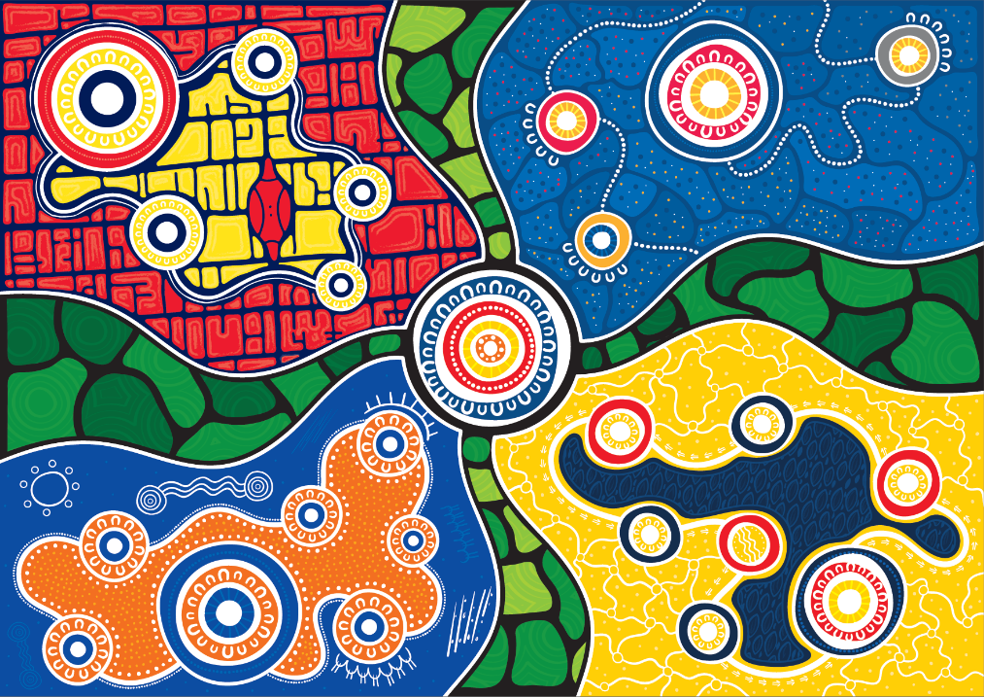

Emergency Services Artwork - developed for the emergency services by Ngarrindjeri Artist Jordan Lovegrove from Ochre Dawn, a South Australian based 100% Aboriginal owned and managed company.

Contents
Emergency Services Artwork 3
Statement from the Chief Executive Officer, Reconciliation Australia 3
Our Businesses 5
Our Reconciliation Action Plan 6
Our Journey 7
Where are we currently? 7
Our partnerships and current activities 8
Relationships 9
Respect 10
Opportunities 12
Governance 14

Emergency Services Artwork
The artwork is presented as a whole but has four discrete sectors within the whole – each representing one of the emergency services agencies.
Going clockwise from the top right the agencies represented are the MFS, SAFECOM, CFS and SES respectively. The MFS quadrant represents the gridlines of urban Adelaide, the central meeting place of the MFS Headquarters with the Kaurna Shield in Tarntanyangga (Victoria Square) drawn by Kaurna artist Lawson Dodd out of respect to the traditional owners and their role in Adelaide. The larger circle in the MFS quadrant represents a central meeting place and the headquarters of the MFS, with the smaller circular meeting places representing the different communities across South Australia that the MFS operates within and services, which are all intimately connected. The SAFECOM quadrant is represents another central, larger meeting place connecting the agency with the other three partner emergency service agencies and the connections the linkages and pathways they share.
We acknowledge the Traditional Owners of the land on which our Emergency Services operate, recognising their continuing connection to land, water, and community.
We pay respect to Elders, past, present, and emerging. We celebrate the stories, culture, and traditions of Aboriginal and Torres Strait Islander Elders of all communities who also work and live on this land.
We, the Emergency Services Sector, are committed to ensuring that the voices, aspirations and needs of Aboriginal and Torres Strait Islander peoples are reflected in our work as we commence on our journey of reconciliation.
Julia Waddington-Powell, Chief Executive SAFECOM
Michael Morgan, Chief Officer, SA Metropolitan Fire Service
Mark Jones, Chief Officer, SA Country Fire Service
Chris Beattie, Chief Officer, SA State Emergency Service

Statement from the Chief Executive Officer, Reconciliation Australia
Reconciliation Australia welcomes the South Australian Fire and Emergency Services Commission to the
Reconciliation Action Plan (RAP) program with the formal endorsement of its inaugural Reflect RAP.
The South Australian Fire and Emergency Services Commission joins a network of more than 1,100 corporate, government, and not-for-profit organisations that have made a formal commitment to reconciliation through the RAP program. Since 2006, RAPs have provided a framework for organisations to leverage their structures and diverse spheres of influence to support the national reconciliation movement. The program’s potential for impact is greater than ever, with close to 3 million people now working or studying in an organisation with a RAP.
The four RAP types — Reflect, Innovate, Stretch and Elevate — allow RAP partners to continuously develop and strengthen reconciliation commitments in new ways. This Reflect RAP will lay the foundations, priming the workplace for future RAPs and reconciliation initiatives.
The RAP program’s strength is its framework of relationships, respect, and opportunities, allowing an organisation to strategically set its reconciliation commitments in line with its own business objectives, for the most effective outcomes.
These outcomes contribute towards the five dimensions of reconciliation: race relations; equality and equity; institutional integrity; unity; and historical acceptance.
It is critical to not only uphold all five dimensions of reconciliation, but also increase awareness of Aboriginal and Torres Strait Islander cultures, histories, knowledge, and leadership across all sectors of Australian society.
This Reflect RAP enables the South Australian Fire and Emergency Services Commission to deepen its understanding of its sphere of influence and the unique contribution it can make to lead progress across the five dimensions. Getting these first steps right will ensure the sustainability of future RAPs and reconciliation initiatives, and provide meaningful impact toward Australia’s reconciliation journey.
Congratulations South Australian Fire and Emergency Services Commission, welcome to the RAP program, and I look forward to following your reconciliation journey in the years to come.
Karen Mundine
Chief Executive Officer
Reconciliation Australia

Our Businesses
The South Australian Fire and Emergency Services Commission (SAFECOM) provides corporate and operational support services that are integral in allowing the Emergency Service Organisations (ESO’s), which include the South Australian Country Fire Service (CFS), South Australian Metropolitan Fire Service (MFS) and South Australian State Emergency Service (SES), to provide the frontline services that directly support and protect the community of South Australia.
Executive, senior management of the CFS, SES and MFS and staff of the CFS and SES are co-located with SAFECOM staff in the Emergency Services Headquarters at Keswick. In addition, CFS has six regional office facilities, 430 regional stations and a State Training Centre at Brukunga; MFS has 20 metropolitan stations, 17 regional stations and a Training Facility at Angle Park and SES has 73 units.
The CFS is an all-hazards agency providing response and prevention services to bushfire and structure fires and response services to motor vehicle fires, road crash rescue and hazardous material spills.
The MFS is the primary provider of urban firefighting services to the State of South Australia and a statutory authority committed to protecting life, property and the environment from fire and other emergencies. The role of the fire service includes prevention and education, preparedness, response, and recovery activities.
The SES has a number of legislative roles, including exercising responsibilities as Control Agency for floods, extreme weather and structural collapse. SES is also a Hazard Leader for extreme weather including storms and heatwaves. Operational functions include responding to floods and storms; assisting police and the two fire agencies in dealing with any emergency; as well as assisting in carrying out prevention, preparedness, response, and recovery operations and undertaking rescues.
The Emergency Services Sector (ESS) serves all South Australia and participates in National co-operative efforts which address the prevention, preparedness, response and recovery of Emergency Management.
From a combined staff of 1651 (MFS, CFS, SES, SAFECOM) only 7 staff, 0.42% of the workforce, identify as Aboriginal and/or Torres Strait Islander people.
We are working towards improving our data capture for our volunteers in the Emergency Services but at this time cannot provide reliable statistics on the cultural heritage of our volunteers
.

Our Reconciliation Action Plan
Our Reconciliation Action Plan (RAP) Champion is the Chief Officer and Chief Executive of the SA Metropolitan Fire Service. A Reconciliation Working Group (RWG), with representation from each of the four agencies, has been formed along with Terms of Reference. The RWG members include the Manager People Services, Manager Volunteer Services Group, Manager, Facilities and Procurement, Deputy Chief Officer CFS, Manager Corporate Services SES, Diversity & Inclusion Project officer MFS, Diversity & Inclusion Project Manager MFS, and the Project Officer SAFECOM. The Terms of Reference have been written to provide a set of rules around membership, representation, structure, reporting requirements and the intention of the RWG.
The Emergency Services Sector (ESS) RAP aims to (but not limited to):
- Outline, encourage and support ESS Volunteers and staff to better reflect the diverse communities we seek to protect, engage, and support through our equality, diversity, and inclusion initiatives and by increasing engagement and participation from underrepresented demographics in our organisations.
- Supporting, encouraging, and enabling our workforce to work with and empower South Australian Aboriginal and Torres Strait Islander people to assist in the improvement of their life experience. There are and have been many successful programs, relationships, projects etc. which have and continue to connect our organisations with Aboriginal and Torres Strait Islander communities. In addition, our organisations welcome support and encourage volunteers. We hope that working through the RAP in a co-ordinated, consistent, and public way we can enhance what we already have and grow our inclusiveness, knowledge, respect, and representation.
- We are committed to continue our learning about and recognition of the value of Indigenous land and fire management practices to mitigate the effects of bushfires and improve disaster resilience. Our organisations seek to continue engaging with Traditional Owners to explore the relationship between Indigenous land management and disaster resilience.
- In our role as the Emergency Services, we have an obligation to work with communities to prepare them for disasters, respond to disasters and help them recover from experiencing disasters. As a sector we seek to improve and strengthen our connection to the Indigenous people we serve to better understand their needs and how we can fulfil our role effectively, collaboratively, and culturally appropriately.
- As South Australian Government agencies we are both responsible and committed to participating with and supporting the goals of the Aboriginal Affairs Action Plan with this plan being a key part of that commitment.

Our Journey
Our approach to developing this RAP is staged to ensure application and commitment across all organisations within the ESS. The ESS comprises of three Emergency Service Agencies; the CFS, SES and MFS; and is enabled by the corporate functions of SAFECOM. For the purposes of this RAP we are operating as one entity, the ESS.
Whilst we are State Government Organisations, we are also federated community organisations with volunteer workforces. Our organisations are grass roots organisations, created and developed from a variety of communities with strong cultural identities and long histories which are specific to their local environments.
In summary, we have 3 focus areas in which we will expand and strengthen our activities as we work through the successive RAP process:
- Corporate
- Grass roots
- Public

Where are we currently?
We:
- Are at the REFLECT stage of our journey and our early conversations are very encouraging.
- Have unanimous and enthusiastic support expressed by our Leadership (Ministers, Chief Executives, Chief Officers, Deputy Chief Officers, Commanders, and Executive Staff).
- Have Indigenous brigades and units in the Anangu Pitjantjatjara Yankunytjatjara (APY) lands.
- Celebrate NAIDOC Week and National Reconciliation Week to varied levels.
- Support culturally inclusive safety messaging in language/s.
- Perform skills exchange activities and traditional land management and burning techniques in the fire management space.
- Aim to support Aboriginal and Torres Strait Islander owned business through our procurement processes where possible.
- Do not have a formal statement of intention in place.
- Do not have any inclusion or participation targets set other than our commitment to reflect the South Australian community that we serve.
- Do not currently have any Aboriginal or Torres Strait Islander representation in our leadership teams
- Have limited engagement and formal relationships with community leaders or organisations to work towards our goals.

Our Partnerships and Current Activities
We have several partnership and activities currently underway including, but not limited to:
The ESS has engaged with Ochre Dawn Creative Industries to guide Indigenous representation in our new Headquarters project.
The Mimili CFS Brigade is a mixed sex brigade with female firefighters trained separately and empowering women to respond to fires in Indigenous Communities where there are taboos about working with men in certain contexts or at certain times or when men are away from the community on men’s business.
The Waru Pulka Kampapai Campaign with Allinytjara Wilurara Natural Resources Management Board is a translated bushfire safety campaign in language.
Several CFS Brigades are Indigenous led and run on the APY lands actively supported by CFS, they are located at Pukatja, Mimili, Kaltjiti, Pip/Kalka.

Relationships
Action | Deliverable | Timeline | Responsibility
1. Establish and strengthen mutually beneficial relationships with Aboriginal and Torres Strait Islander stakeholders and organisations. | Identify Aboriginal and Torres Strait Islander stakeholders and organisations within our local area or sphere of influence. | July 2022 | SAMFS Chief Officer (RAP Champion)
 | Research best practice and principles that support partnerships with Aboriginal and Torres Strait Islander stakeholders and organisations. | July 2022 | SAMFS Chief Officer (RAP Champion)
2. Build relationships through celebrating National Reconciliation Week (NRW). | Circulate Reconciliation Australia’s NRW resources and reconciliation materials to our staff. | May 2023 | Chair Reconciliation Working Group
 | RAP Working Group members to participate in an external NRW event. | May 2023 | Executive Sponsor Reconciliation Working Group
 | Encourage and support staff and senior leaders to participate in at least one external event to recognise and celebrate NRW. | May 2023 | SAFECOM Board Chair, SAFECOM Chief Executive
3. Promote reconciliation through our sphere of influence. | Communicate our commitment to reconciliation to all staff. | July 2023 | Chief Executive SAFECOM  Executive Sponsor Reconciliation Working Group
 | Identify external stakeholders that our organisation can engage with on our reconciliation journey. | September 2022 | MFS Cultural Awareness Project Officer
 | Identify RAP and other like-minded organisations that we could approach to collaborate with on our reconciliation journey. | September 2022 | SAMFS Chief Officer (RAP Champion)

Respect
Action | Deliverable | Timeline | Responsibility
4. Increase understanding, value and recognition of Aboriginal and Torres Strait Islander cultures, histories, knowledge and rights through cultural learning. | Develop a plan for increasing understanding, value and recognition of Aboriginal and Torres Strait Islander cultures, histories, knowledge and rights within our organisation. | September 2022 | MFS D&I Project Manager
 | Roll out cultural awareness training across the sector with a target completion of 90% and all new employees to undertake the training as part of their induction process | September 2022 | Executive Sponsor Reconciliation Working Group
5. Demonstrate respect to Aboriginal and Torres Strait Islander peoples by observing cultural protocols. | Develop an understanding of the local Traditional Owners or Custodians of the lands and waters within our organisation’s operational area. | August 2022 | MFS – Cultural Awareness Project Officer  SES – Manager Corporate Services  CFS – R4 Outback Officer
 | Increase staff’s understanding of the purpose and significance behind cultural protocols, including Acknowledgement of Country and Welcome to Country protocols. | September 2022 | MFS Cultural Awareness Project Officer
6. Build respect for Aboriginal and Torres Strait Islander cultures and histories by celebrating NAIDOC and National Reconciliation Week. | Raise awareness and share information amongst our staff about the meaning of NAIDOC and National Reconciliation Week. | July 2023 | MFS – Diversity and Inclusion Project Manager  SES – Manager Corporate Services  CFS – Executive Director, Business  SAFECOM – Manager People Services
 | Introduce our staff to NAIDOC and Reconciliation Week by promoting external events in our local area. | July 2023 | MFS – Diversity and Inclusion Project Manager  SES – Manager Corporate Services  CFS – Executive Director, Business  SAFECOM – Manager People Services
 | RAP Working Group to participate in an external NAIDOC Week event. | July 2023 | Executive Sponsor Reconciliation Working Group

Opportunities
7. Promote Aboriginal and Torres Strait Islander employment. | Develop a framework that sets out how the Sector will promote for Aboriginal and Torres Strait Islander employment and its benefits. | July 2022 | SAFECOM Manager People Services
 | Develop a targeted Recruitment Strategy and Plans for the attraction and retention of Aboriginal and Torres Strait Islander volunteers. | February 2023 | CFS Regional Volunteer Officers  CFS Outback Officer  SES District Officer Flinders Gulf within North Region
8. Increase Aboriginal and Torres Strait Islander supplier diversity to support improved economic and social outcomes. | Develop a business case for procurement from Aboriginal and Torres Strait Islander owned businesses. | July 2022 | SAFECOM Procurement Manager
 | Ensure procurement activities actively seek to identify Aboriginal and Torres Strait Islander owned businesses at early stages where possible. | July 2022 | SAFECOM Procurement Manager
 | Utilise the South Australian Aboriginal Business Register hosted on the Office of the Industry wherever possible for supplied services.  Consider the Industry Participation Policy which allows:  - Agencies can procure directly from businesses listed on South Australia’s online Aboriginal Business Register for goods and services up to the value of $220,000  For tenders greater than $220,000, consider lifting the Industry Participation weighting of tenders so Aboriginal businesses, and businesses with high Aboriginal employment or subcontracting, are more likely to win tender contracts. | July 2022  Review in May 2023 | SAFECOM Procurement Manager

Governance
Action | Deliverable | Timeline | Responsibility
9. Establish and maintain an effective RAP Working Group (RWG) to drive governance of the RAP. | Maintain the RWG to govern RAP implementation. | December 2022 | MFS Chief Officer (RAP Champion)
 | Review Terms of Reference and membership for the RWG. | September 2022 | MFS Chief Officer (RAP Champion)
 | Maintain Aboriginal and Torres Strait Islander representation on the RWG. | December 2022 | MFS Chief Officer (RAP Champion)
10. Provide appropriate support for effective implementation of RAP commitments. | Define resource needs for RAP implementation. | Ongoing per initiatives- review May 2023 | MFS Chief Officer (RAP Champion)
 | Engage senior leaders in the delivery of RAP commitments. | July 2022 | Chief Executives/Chief Officers
 | Define appropriate systems and capability to track, measure and report on RAP commitments. | October 2022 | MFS Chief Officer (RAP Champion)
11. Build accountability and transparency through reporting RAP achievements, challenges and learnings both internally and externally. | Complete and submit the annual RAP Impact Measurement Questionnaire to Reconciliation Australia.  Compare annual results to drive continuous improvement and reflection. | September 2022  July 2023 | MFS Chief Officer (RAP Champion)  MFS Chief Officer (RAP Champion)
12. Continue our reconciliation journey by developing our next RAP. | Register via Reconciliation Australia’s website to begin developing our next RAP. | January 2023 | MFS Chief Officer (RAP Champion)
For Further Information:
www.safecom.sa.gov.au
www.cfs.sa.gov.au
www.mfs.sa.gov.au
www.ses.sa.gov.au
Phone: 08 8115 3909

